REVERSE PRESSURE SOFTENING
K. Jean Cotterman RNC, IBCLC, (mellomom@juno.com)

What is it?
Reverse pressure softening is a new way to soften the circle around your nipple (the a-re-o-la) to make latching and getting your milk out easy while your baby and you are learning. Latching shouldn’t be painful. If your areola is soft enough to change shape while feeding, it helps your baby gently extend your nipple deep inside his mouth, so his tongue and jaws can press on milk ducts under the areola.
(These motions differ from those that artificial nipples force a baby to use.)

This new method is not the same as removing milk with your fingers. Don’t expect milk to come from your nipple while you soften your areola this way. (But it’s OK if some milk does come out.)

When is it helpful?
Try reverse pressure softening in the early days after birth if you begin to notice firmness of the areola, latch pain or breast fullness. (This full feeling is only partly due to milk. Delayed or skipped feedings may also cause the tissue around your milk ducts to hold extra fluid much like a sponge does. This fluid never goes to your baby.) Intravenous (IV) fluids, or drugs such as pitocin may cause even more retained tissue fluid, which often takes 7-14 days to go away. Avoid long pumping sessions and high vacuum settings on breast pumps to prevent extra swelling of the areola itself.

Feel your areola and the tissue deeper inside it. Is it soft and easy to squeeze, like your earlobe or your lip? Or does it feel firmer and harder to compress, like your chin? if so, it’s time to try reverse pressure softening just before each time you offer your baby your breast. (Some mothers soften their areola before feeding, for a week or longer, till swelling goes down, baby can be heard swallowing milk regularly, and latching is always painfree without softening first.)

Why does it work?
Reverse pressure softening briefly moves some swelling backward and upward into your breast to soften your areola so it can change shape and extend your nipple. It sends a special signal to the back of your breasts to start moving milk forward (let-down reflex) where your baby’s tongue can reach it. It also makes it easy to remove milk with your fingertips or with short periods of slow gentle pumping, combined with gentle forward massage of the upper breast, if you need to remove milk for your baby.

Where should I press?
It is most important to soften the areola in the whole one-inch area all around where it joins your nipple. Soften even more of the areola if you wish. You may also want to soften a place where your baby’s chin will be able to move easily against the breast. Reverse pressure softening should cause no discomfort.

How do I do REVERSE PRESSURE SOFTENING?
K. Jean Cotterman RNC, IBCLC (mellomom@juno.com)
Illustrations by Kyle Cotterman, Dayton, Ohio
- You (or your helper, from in front, or behind you) choose one of the patterns pictured.
- Place the fingers/thumbs on the circle touching the nipple.
- (If swelling is very firm, lie down on your back, and/or ask someone to help by pressing his or her fingers on top of your fingers.)
- Push gently but firmly straight inward toward your ribs.
- Hold the pressure steady for a period of 1 to 3 full minutes.
- Relax, breathe easy, sing a lullaby, listen to a favorite song or have someone else watch a clock or set a timer. To see your areola better, try using a hand mirror.
- It’s OK to repeat the inward pressure again as often as you need. Deep “dimples” may form, lasting long enough for easy latching. Keep testing how soft your areola feels.
- You may also press with a soft ring made by cutting off half of an artificial nipple.
- Offer your baby your breast promptly while the circle is soft.

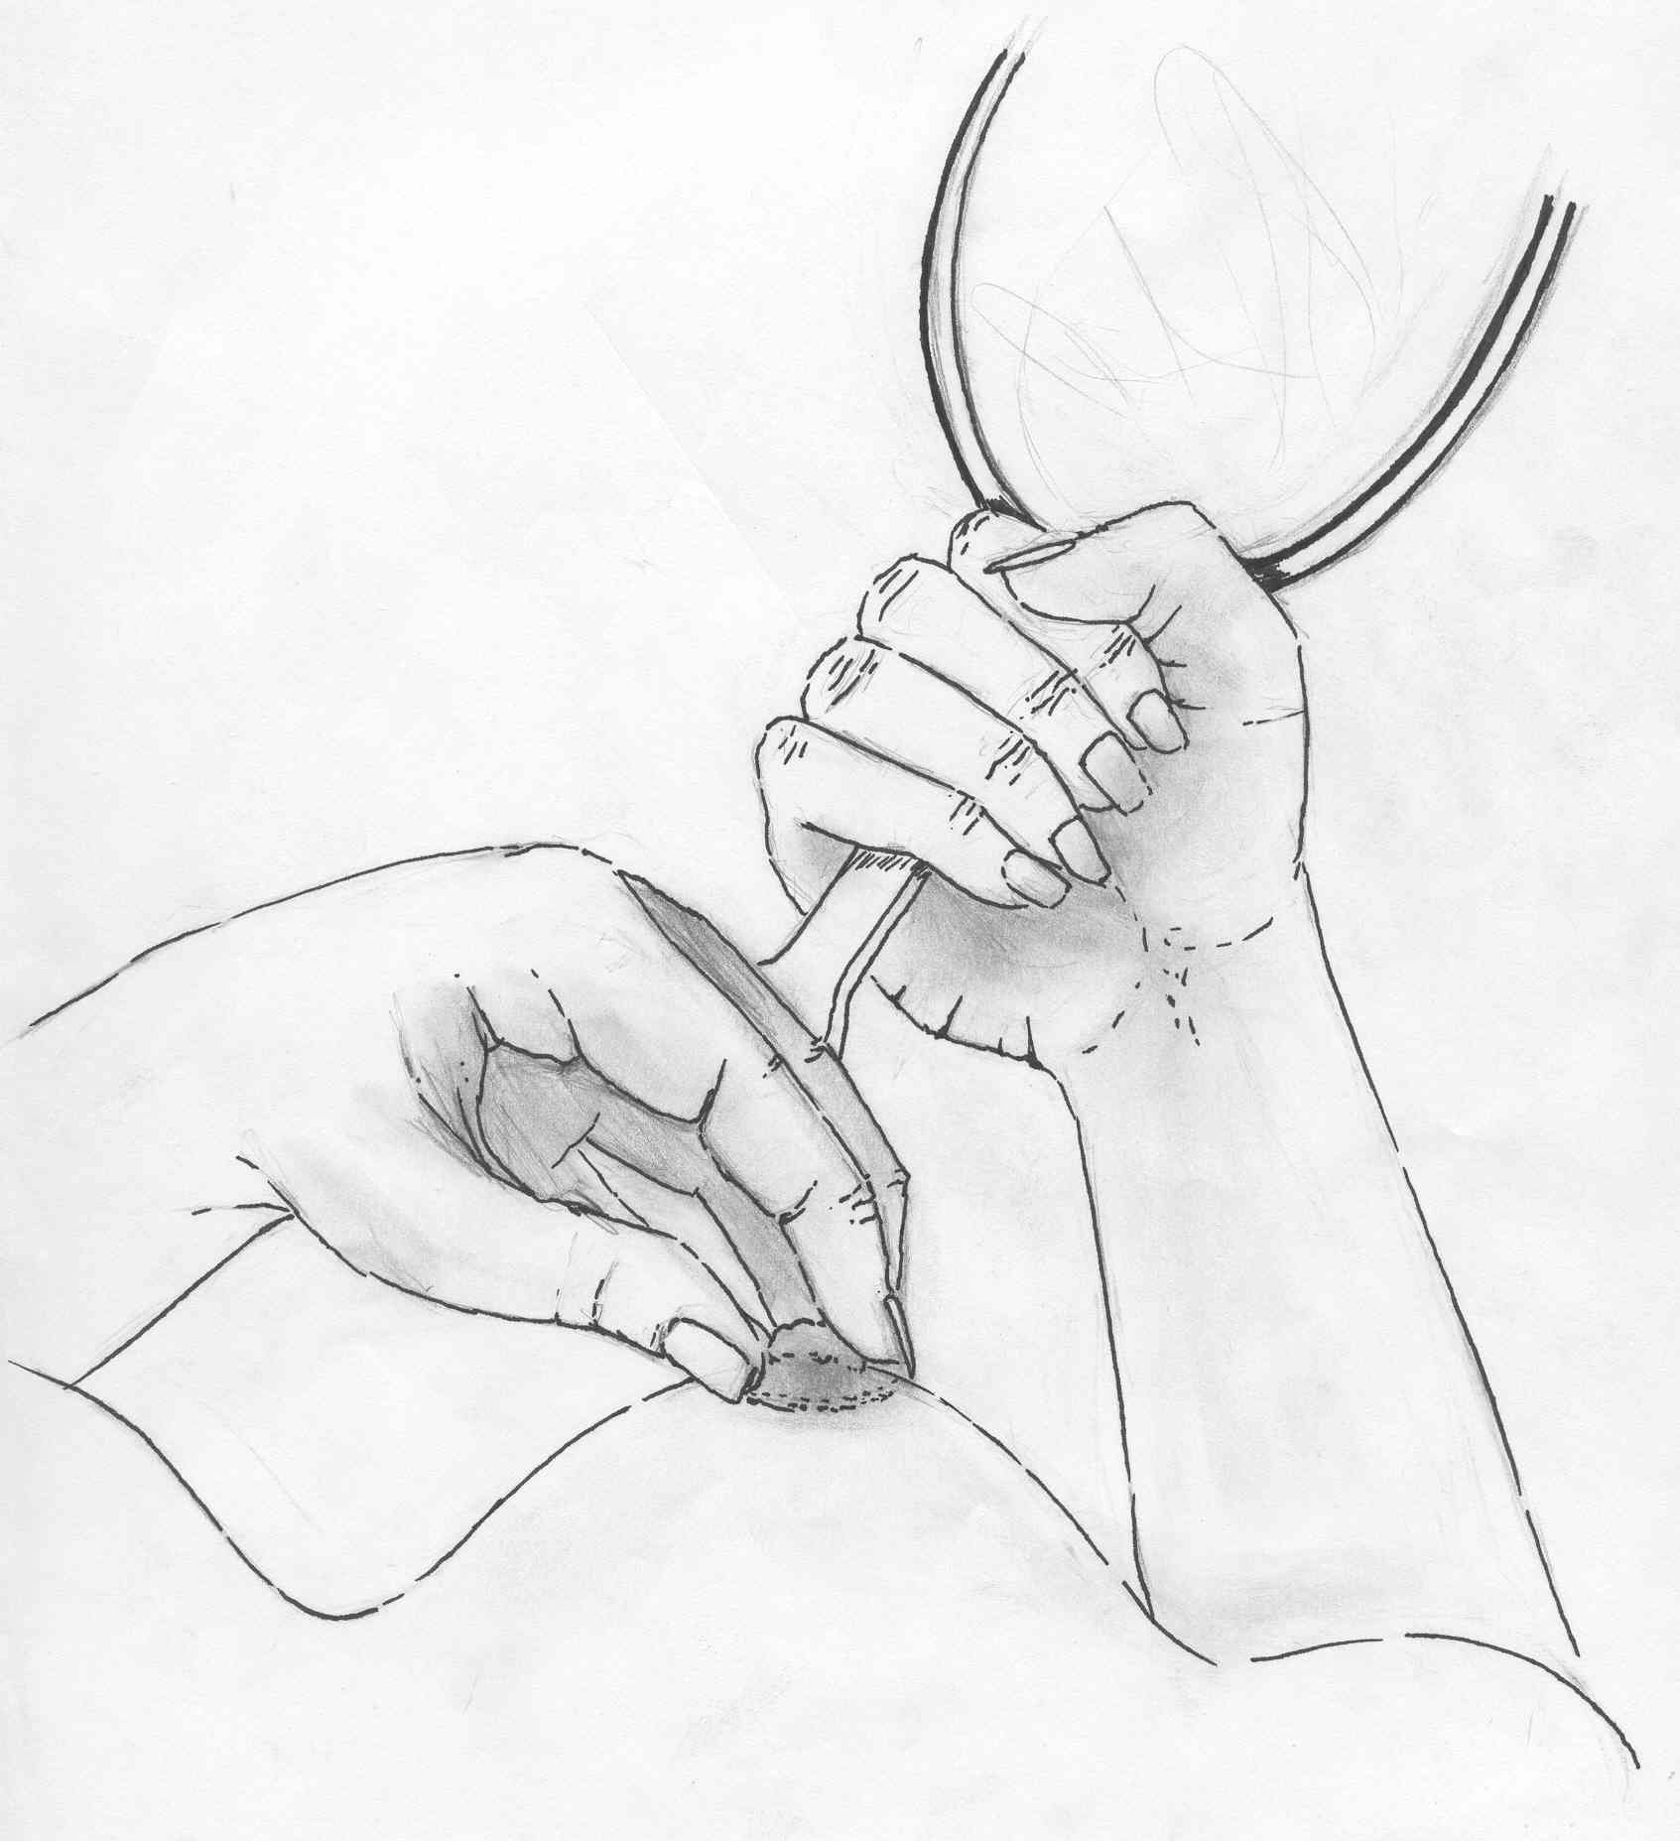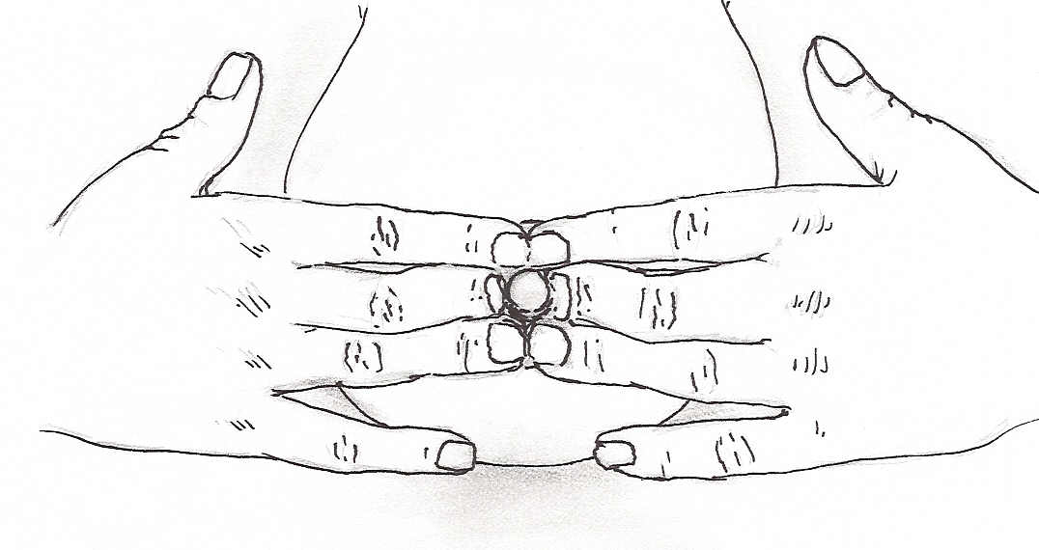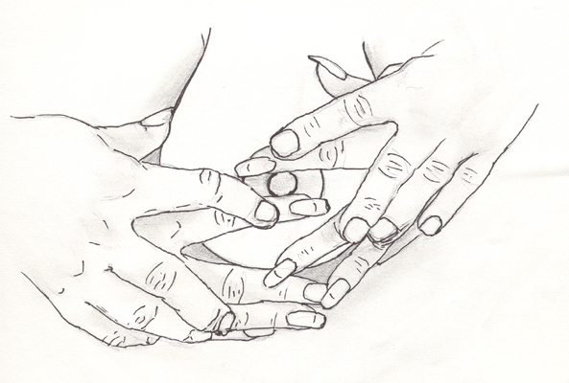
One handed “flower hold” Two handed, one-step method (You may ask
Fingernails short, Fingernails short, someone to help
Fingertips curved, Fingertips curved, press by placing
placed where baby’s Each one touching fingers or thumbs
tongue will go the side of nipple on top of yours.)

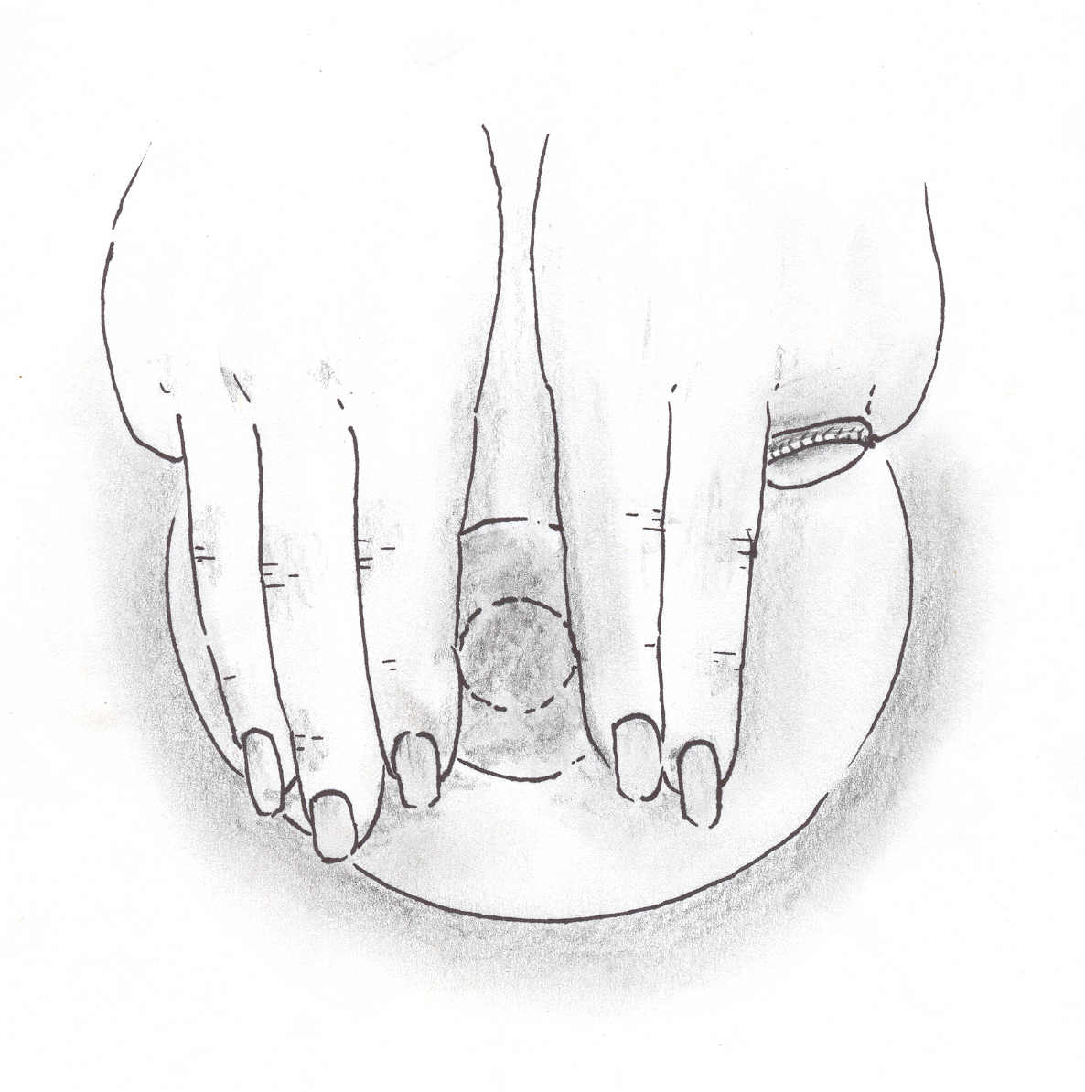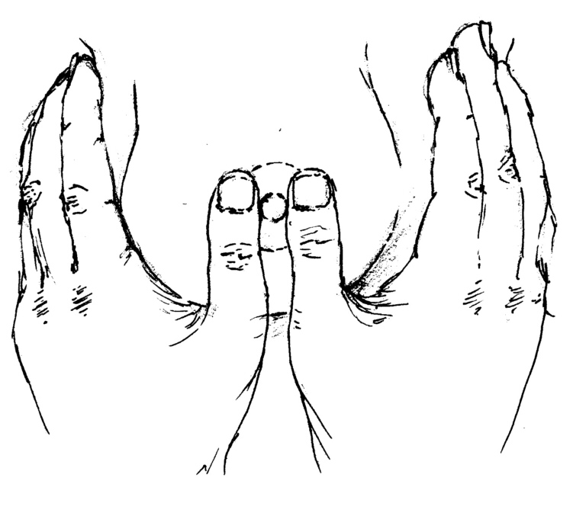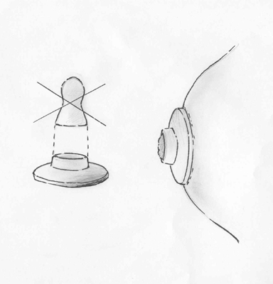
Two step method, two hands, Two step method, two hands, Soft ring method.
using 2 or 3 straight fingers using straight thumbs, base Cut off bottom half
each side, first knuckles of thumbnail even with side of an artificial nipple
touching nipple. Move ¼ turn, of nipple. Move ¼ turn, repeat, to place on areola to
repeat above & below nipple. thumbs above & below nipple press with fingers
© 2004 Lactation Education Consultants. May be reproduced for non-commercial purposes.

